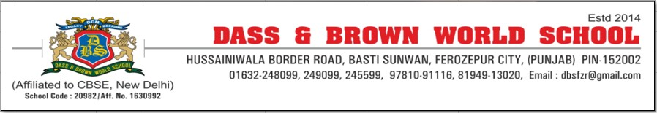

SMC Members - session 2021-22
Sr no | Name | Father's / Spouse Name | Designation | Occupation | Address | Off. Phone No | Res. Phone No.
1 | Mr.Surinder Bajaj | Sh Mulkh Raj | President | Senior Advocate | 19, New Model Town , Ferozepur City. | 9814921012 | 9814921012
2 | Mr.Anirudh Gupta | Sh Varinder Kumar Gupta | Vice – President/ Society Representative | CEO | 45, Dass road , Near Railway Bridge , Ferozepur city | 9814010752 | 163224559
3 | Mr.Ranjan Sharma | Sh Mohinder Nath Sharma | Manager | Businessman | 69, Model Town , Ferozepur City | 9815160736 | 9815160736
4 | Ms Yachna Chawla | Subash Chander Chawla | Secretary (Ex-officio) | Principal | DCM Westend Complex, Border road , Ferozepur city | 8725006351 | 8725006351
5 | Dr Ramnita Saini Sharda | Mr Sanjiv Sharda | Educationist | Principal | Principal House, Dev Samaj College, Ferozepur City | 9915297103 | 9915297103
6 | Dr Satinder Kaur | Dr Jaswinder Singh | Member | Doctor | #29 C, PUDA Colony, Baghi Road, Ferozepur City | 9855597235 | 9855597235
7 | Mr Jatin Sanan | Mr Varinder Sanan | Parent Representative | Businessman | 29/29, MALWAL ROAD, FZR. CITY | 8968705555 | 8968705555
8 | Ms. Bhavna Gupta | Mr. Saren Gupta | Member | Social Worker | 136 Cement House, Ferozepur Cantt | 9915215281 | 9915215281
9 | Dr. Sheel Sethi | Sh Chaman Lal Sethi | Member | Doctor | Sheel Nursing Home ,Modal town , Ferozepur city | 9814123681 | 9814123681
10 | Ms. Anuja Garg | Mr Rahul Garg | Member | Social Worker | 150P, Sant Lal Road, Near PNB Bank, Ferozepur Cantt. | 8557800006 | 8557800006
11 | Dr Sonam Chawla | Dr Rohit Chawla | Parent Representative | Dentist | Chawla Forever Smiles, #116 Model Town, Ferozepur City | 8146774405 | 8146774405
12 | Ms. Lata John | Mr. John Alfred | Member | Retd. Lecturer | H.No.-145/7, dhawan Colony, Ferozepur City | 8146272913 | 8146272913
13 | Mr Anoop Sharma | Lt Sh Harmesh Chander | Teacher Representative | Teacher | Nandrajog Lounge, Border road , Ferozepur City | 8195913030 | 8195913030
14 | Mr Subodh Maini | Sh Ramesh Maini | Parent Representative | Businessman | H.No-70 , Bhagat Singh colony, Ferozepur City | 9872183124 | 9872183124
15 | Ms Gazal Gaba | Mr Vikas Gaba | Parent Representative | Businesswoman | #23, PUDA Colony, Baghi Road, Ferozepur City | 9592000425 | 9592000425
16 | Dr Suman Bansal | Dr Shyam Sunder Gupta | Member | Doctor | HKL Pvt Ltd, Adarsh Nagar Guruharsahai. | 9876639109 | 9876639109
17 | Dr.Lalit Sharma | Mr Dev Sharma | Member | Associate Director, SBS | A8, SBS Technical Campus | 9872069500 | 7889128354
18 | Mr. Deepak Sharma | Sh. K.L. Sharma | Member | Educationist | 480, Beri Mohalla, Ferozepur City. | 9855776666 | 9855776666
19 | Dr. Celine | Dr Solomon David | Teacher Representative | Teacher | 308, Frances Newton Mission Hospital, Fzr Cantt. | 9781091116 | 9781091116
20 | Ms Kulwinder Kaur | S. Ajit Singh | Ex-Officio Member | DEO | Subhash Colony, Zira, Distt Ferozepur | 9463239229 | 9463239229
21 | Ms. Harjeet Kaur | Sh. Nihal Singh | Ex-Officio Member | Principal | Priincipal, Kendriya Vidhyalaya.No. 2, Fazilka Road Ferozepur Cantt. Pin Code - 152001 | 01632 - 246123 | 01632 - 246123
22 | Dr Himanshu Monga | Dr RK Monga | Member | Dentist | H.NO DS 4/11, MOHALLA PEERAN WALA, FEROZEPUR CITY | 7888733378 | 788873378

